**Assignment 5**

**Sis Procedures Diagrams**

Dbo.Login

Dbo.Authenticate

Dbo.RemeberLogin

Dbo.LogError

Dbo.LogWarning

Dbo.LogInformation

Dbo.CreateAccount

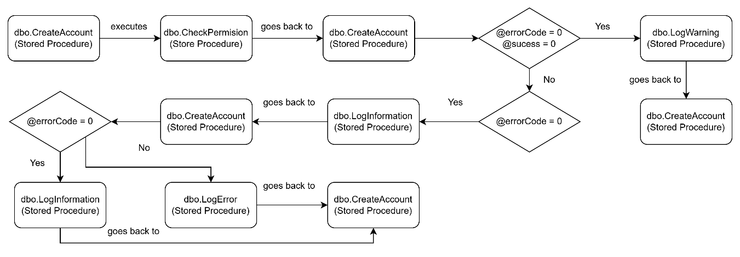

Dbo.CheckPermision

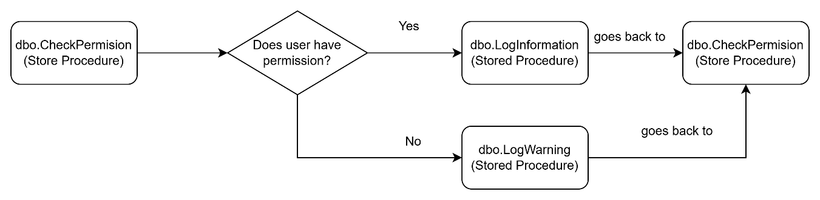

Dbo.RetrieveLoggedUser

Dbo.CreateCustomErrorMessage

Dbo.CreateInvoice

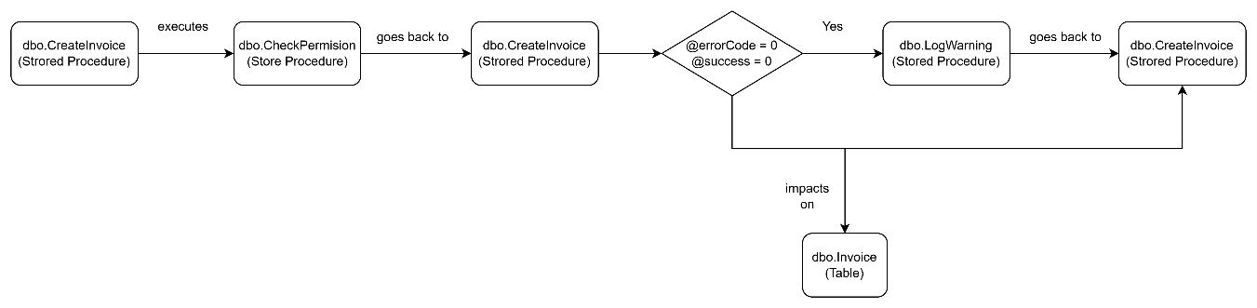

Dbo.AcceptPayment

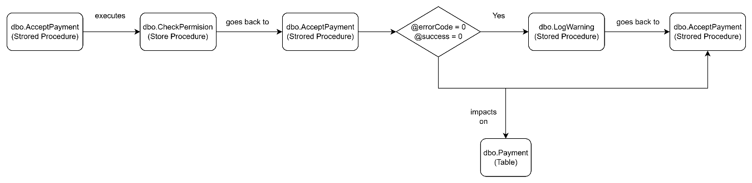

Dbo.AssignRoleToAccount

Dbo.AuditInvoice

Dbo.AuditPayment

Dbo.Logout

**Business Rules**

1. The user must be able to login.
2. While user is Logged, the login must be remembered.
3. Errors must be logged, with an error category.
4. Every answer of any procedure must be logged.
5. Answers must be logged with a category according to its success.
6. The user must be able to create an account.
7. The user that is creating an account must have permission to do it.
8. In case the user has the permission to do it, the account will be created and the answer of the creation logged. Otherwise, the error must be logged.
9. Logged in user may be able to assign a role to another user if he has the permission to do it.
10. The user must be able to accept payments if the user has the right to do it.
11. All invoices must be audited.
12. All payments must be audited.
13. The user may create invoices if he has the right.
14. The user can export the data of selected employees in csv file.
15. The user must be able to log out.